Chris

Fintech Kenya Limited

Abstract

[Draw your reader in with an engaging abstract. It is typically a short summary of the document.   
When you’re ready to add your content, just click here and start typing.]

Internet banking

Manual

Table of Contents

CHAPTER 1: INTRODUCTION 2

CHAPTER 2: ARCHITECTURE 2

CHAPTER 3: ADMIN 2

IB ACCOUNTS 2

VIEW IB ACCOUNTS 2

ADD ACCOUNT 2

SIGNATORIES 2

ADMIN USERS 2

AIR TIMES 2

Nobel 2

SYSTEM CONFIGURATION 2

Audit 2

CHAPTER 4: USER 2

REGISTRATION 2

BALANCES 2

STATEMENT 3

TRANSFERS 5

PAYMENTS 9

Salary Processing 9

School fees payments 15

Vendor payments 15

Utility payments 15

CHAPTER 5: SUPPORT 15

CHAPTER 6: SECURITY 15

# CHAPTER 1: INTRODUCTION

The internet banking system has a simplistic approach to get things done while upholding high security level. Built on mobile first responsive web based technology delivers relative views on different screen sizes.

# CHAPTER 2: ARCHITECTURE

* The system uses user role based authorization and authentication to identify upon successful login and present them with menus relevant to their role in the system.

Eg. Admin user will have a different menu and access to that of an account user.

* The System uses Email address combined with phone number to identify users

# CHAPTER 3: ADMIN

The system shipped with one master admin user responsible for creating other users (admin and account users)

Admin user roles

1. Maintain other admin users
2. Maintain IB accounts (Add, edit, drop…)
3. Maintain system Configuration settings (Master Admin)
4. Upload new scratch cards
5. Maintain below dynamic system parameters
   1. Scratch card denominations
   2. Nobel Commission chart
   3. Utility providers
   4. School accounts
   5. School grades
   6. Mobile services providers
6. Nobel transaction view and reports
7. View audit trail and generate audit reports
8. View system Error logs and report the same

Upon Successful

## IB ACCOUNTS

Upon successful login (Authentication as an admin user – automated), the user is presented with below main **admin menu.**



* Sub Menus
  + Users / Account Manager
    - IB Accounts (All IB Accounts)
    - Account users (IB Account signatories)
    - Admin Users (IB Admin users)

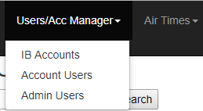

* + Air Times
    - Scratch Cards (All scratch cards)
    - Scratch Card Denominations

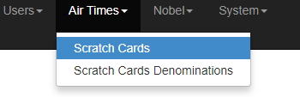

* + Nobel
    - Transactions (all Nobel transactions)
    - Nobel commission Chart (view commission Charge chart)

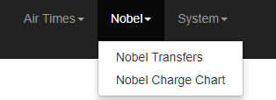

* + System
    - Banks (Later for when Salary will be going to other banks)
    - Utility providers (Liberia Power, Monrovia Water)
    - Mobile providers (Orange, Lonester)
    - Schools (maintain schools)
    - School grades(maintain schools grades)
    - Sys Configs (System Configuration settings)
    - Audit (view audit trails)
    - Emails
    - Error logs

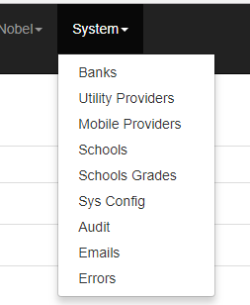

### VIEW IB ACCOUNTS

1. Click on users /Acc manager menu
2. IB Accounts sub menu

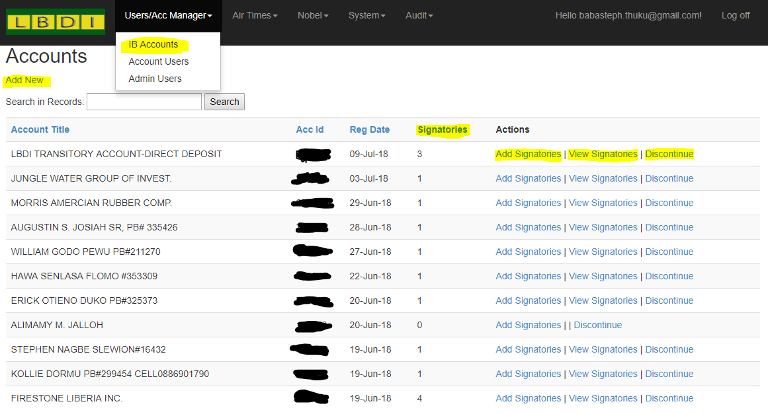

Figure 1: IB accounts view (Highlighted areas represent self-explanatory links)

### ADD ACCOUNT

To register new IB Account

1. Go to Users /Acc Manager menu
2. IB Accounts
3. Click on add new

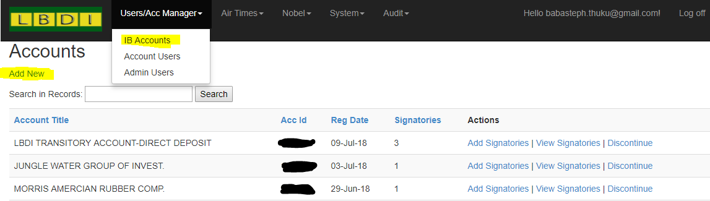

The following page is shown

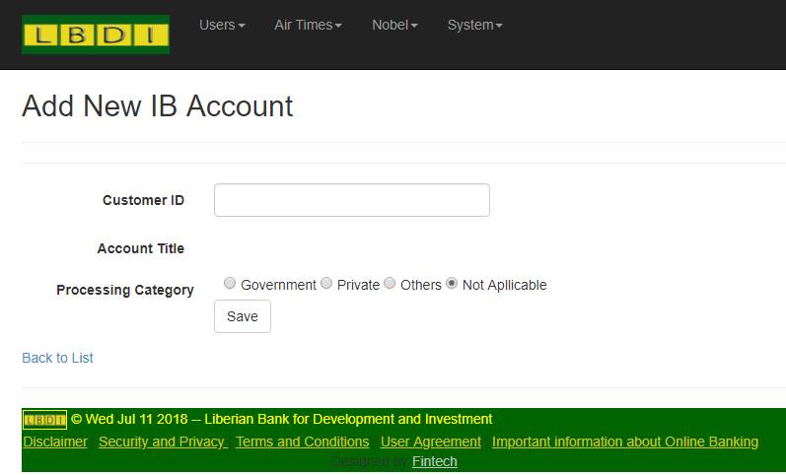

1. Enter the customer id

*After Courser leaves the customer ID input box the number is validated and if correct, the account title displayed. If invalid the same is shown*

1. If the account is corporate and will be processing salaries, choose the salary-processing category so that effective rates will apply on salary processing commission.
2. If personal account leave the default selected option (Not Applicable)
3. Click on save
4. If an error occurs, the display will remain the same and show you the error in red.
5. If successful the view will change to IB accounts view with the new entry as the top most row

**Below functionalities are on the page and are pretty self-explanatory**

* DISCONTINUE ACCOUNT
* RE ACTIVATE DISCONTINUED ACCOUNT
* VIEW ACCOUNT SIGNATORIES
* ADD ACCOUNT SIGNATORIES
* DISABLE SIGNATORY
* RE-ACTIVATE SIGNATORY

## SIGNATORIES

* All
  1. Go to Users /Acc Manager menu
  2. Click on Account users sub menu

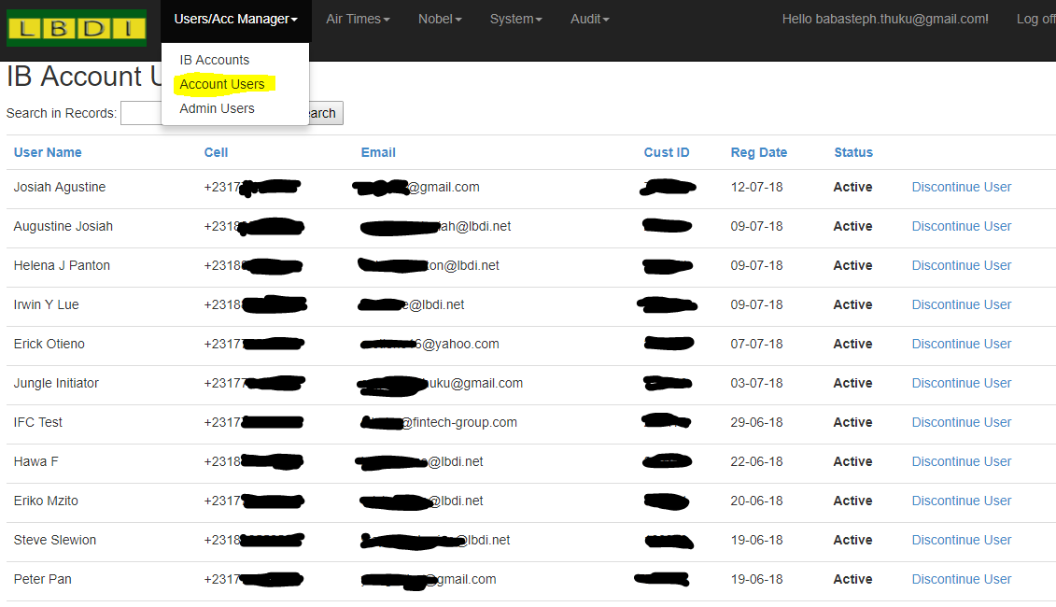

* Account specific signatories
  1. Click on Users/Acc manager Menu
  2. IB Accounts sub menu
  3. On the specific account click on view Signatories

NB you can also Use the search area to search for account and the pagination buttons below

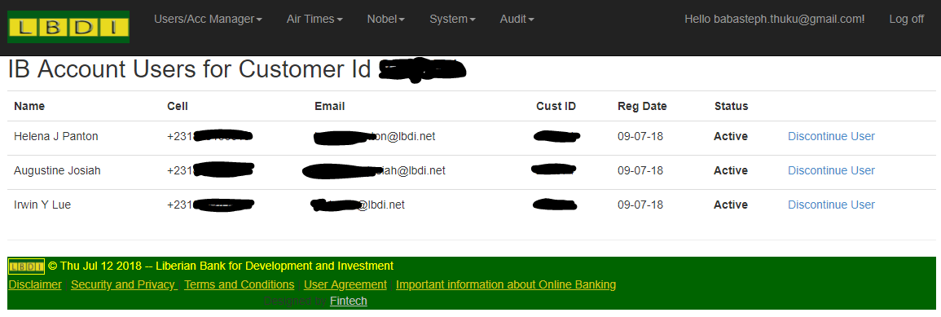

## ADMIN USERS

* Click on Users/ Acc manager menu
* Admin Users Sub menu

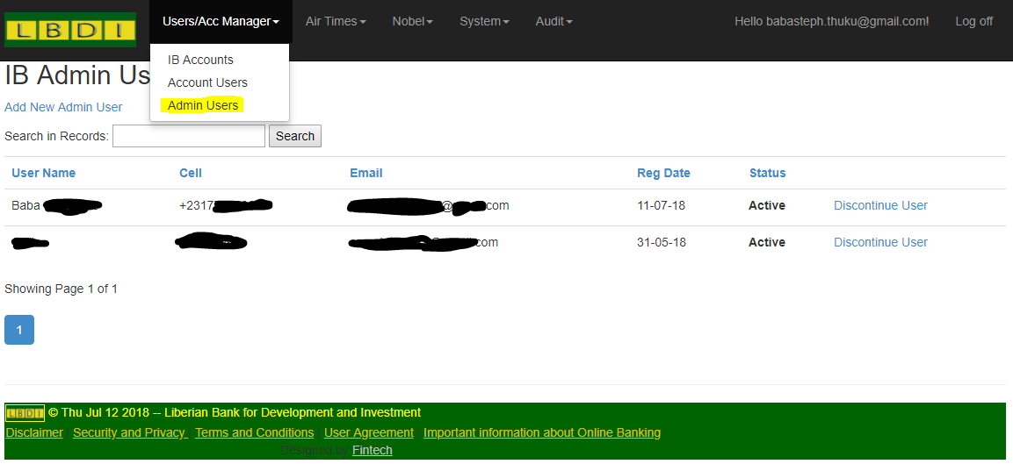

## AIR TIMES

* Air time menu
* Scratch cards sub menu

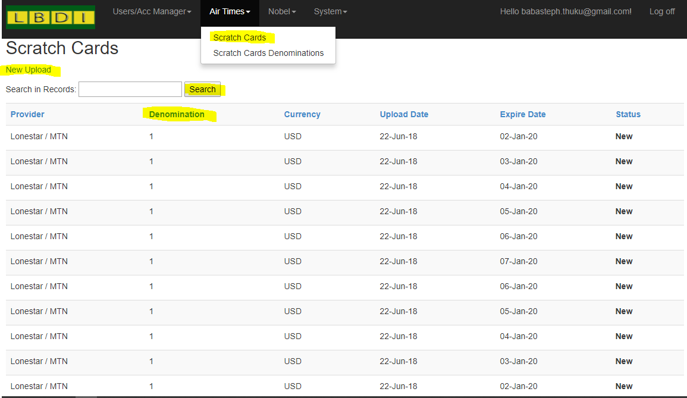

Airtime purchase history and uploads.

Air Time Denominations – This are used to determine viable upload denominations on airtime upload.

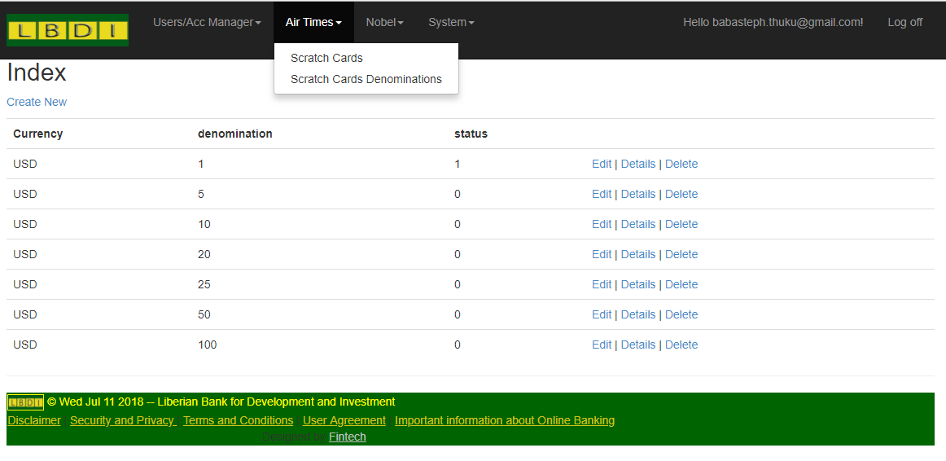

## Nobel

1. Transfers
2. Nobel Menu
3. Nobel transfers

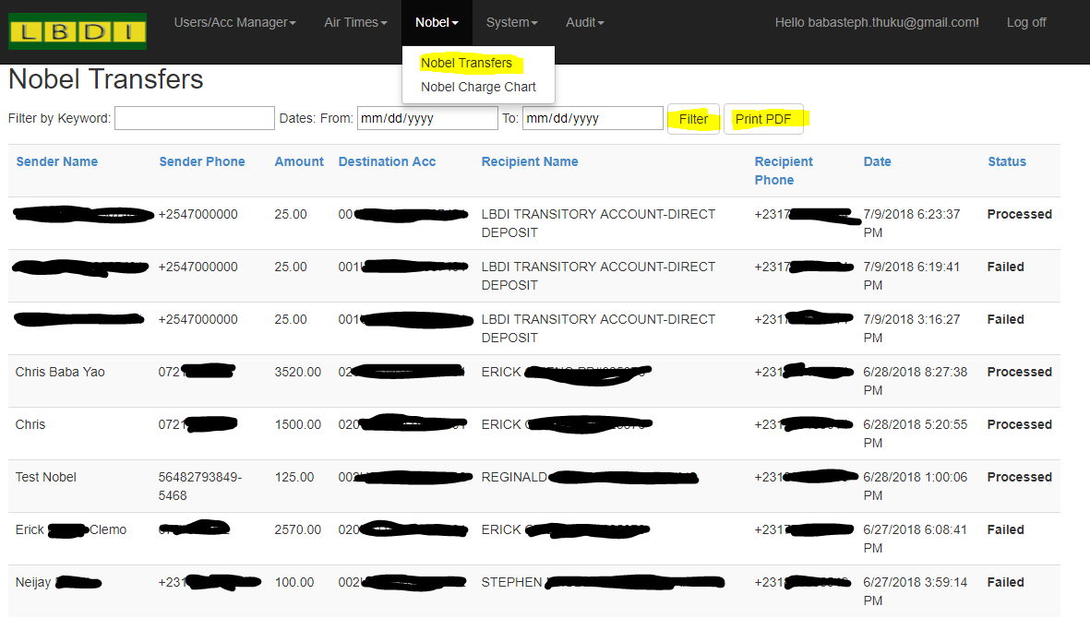

1. Charge chart
   1. Nobel Menu
   2. Nobel Charge Chart

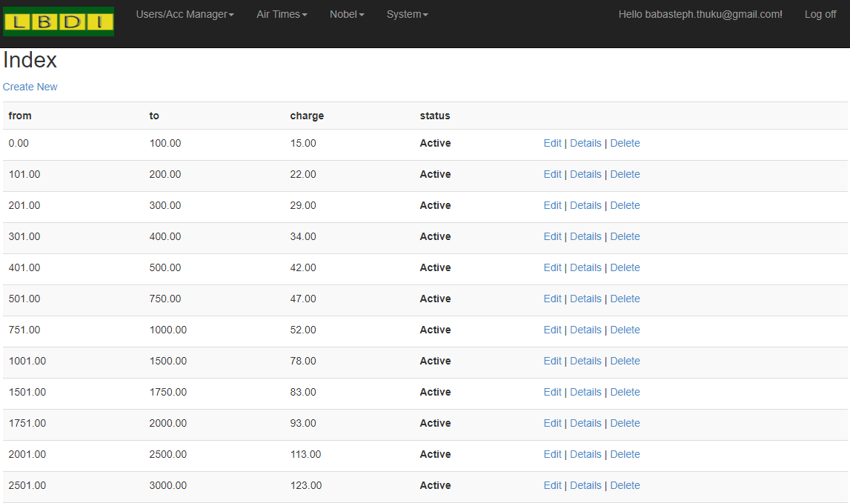

## SYSTEM CONFIGURATION

Contains system parameters that rarely need change

NB: Do not Alter any of these Parameters

## Audit

1. Audit Menu

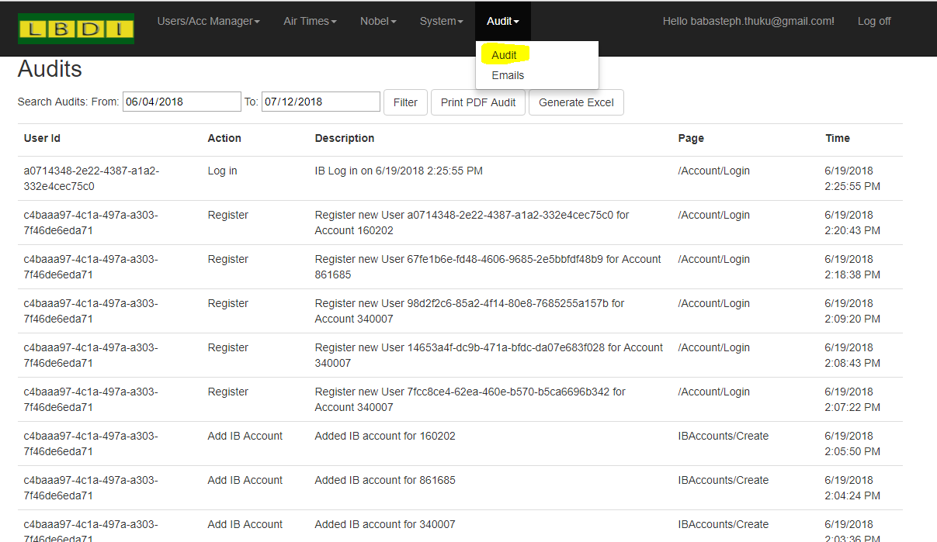

# CHAPTER 4: USER

## REGISTRATION

1. User visits any of our branches and fills in a mobile banking registration form. The following details but not limited to should be provided
   1. Full names
   2. Email address (Unique for every user)
   3. Phone number
   4. Date of birth
   5. Account number (Customer ID)

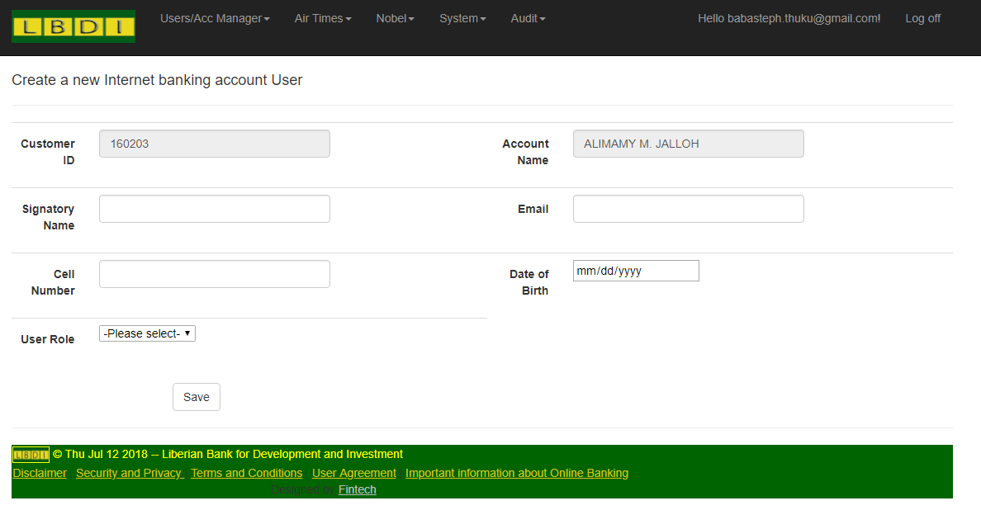

**NB:**

* **For single customer accounts the signatory user role should be *“IbUser”***
* **For corporate users Assign either *“Authorizer, Verifier or Initiator”* Accordingly**

## BALANCES

Click on Accounts menu Balances Sub menu

A list of all your account balances (Available and actual) is displayed

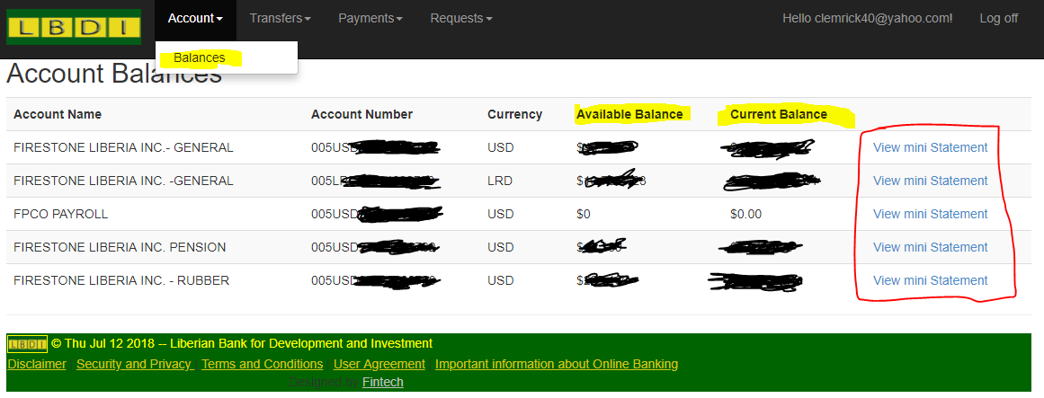

## STATEMENT

For every account displayed in balances an option view mini statement is shown on far right end of each row.



Click on the above link to view the last five transactions of any account

To view full statement select the date rage you wish to view statement and click Show full statement.

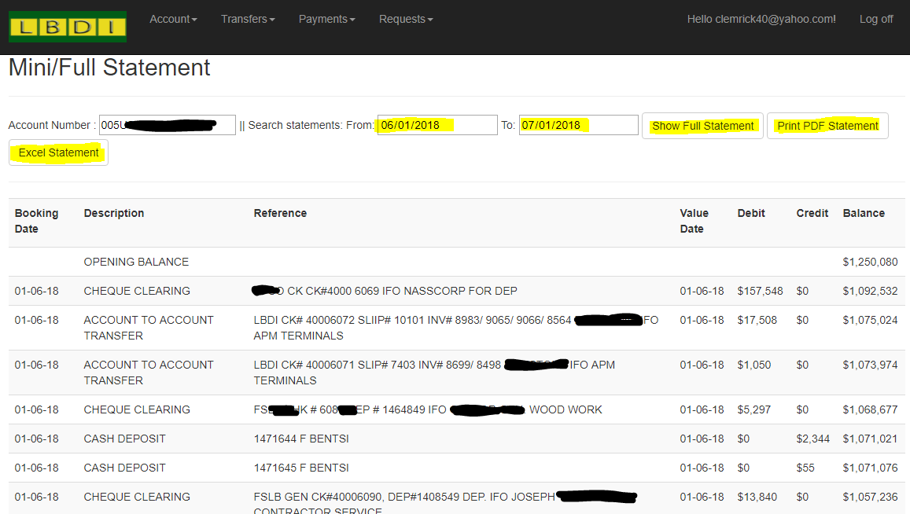

User the Print PDF and excel buttons to generate and download PDF and excel statements respectively

## TRANSFERS

* History
  + Click transfers menu
  + Transfer history

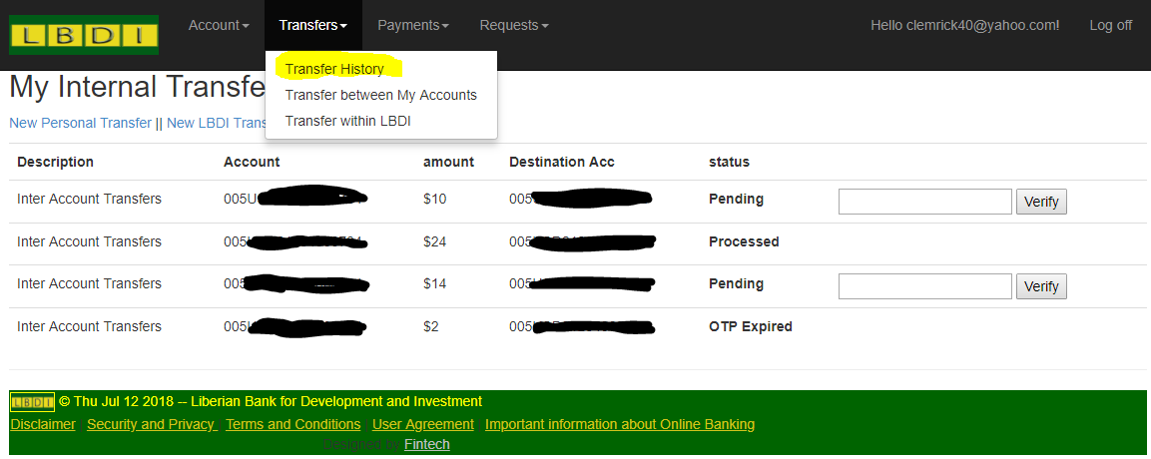

* Inter account transfers
  + Click on transfer menu
  + Transfer between my accounts

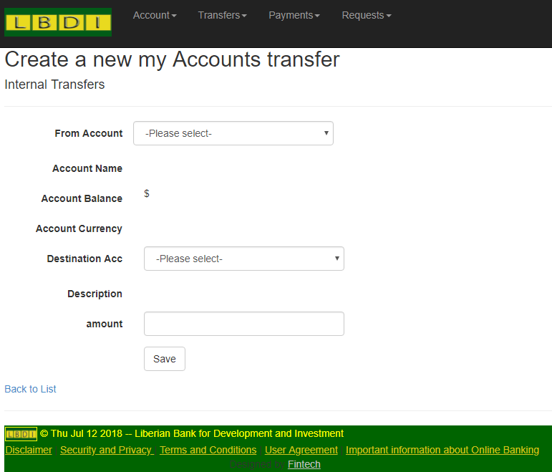

* + Select the from account (debit account)
  + On selection Account name, Available balance and account currency will be displayed
  + The destination account will auto adjust to only show your other accounts of similar currency
  + On selecting the destination account its name will be auto fetched
  + Enter amount and click save

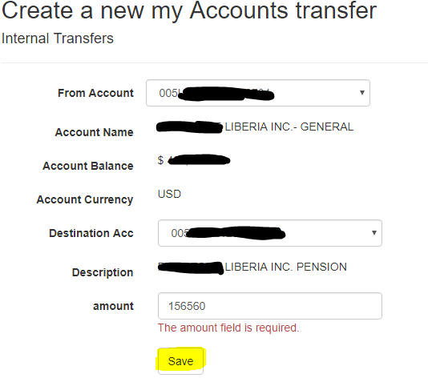

* LBDI transfers
  + Click on transfers
  + Transfer within LBDI sub menu
  + Select the from account (debit account)
  + On selection Account name, Available balance and account currency will be displayed
  + Type the destination account (LBDI Account only)
  + On leaving the cursor the account name will be auto fetched
  + Enter amount and click save

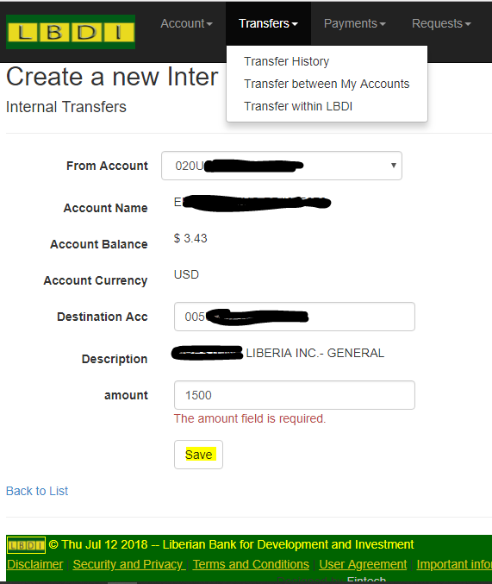

The above transfer processes require OTP authentication to Complete

## PAYMENTS

## Salary Processing

* This is reserved for cooperate accounts only.
* Click payments menu Salary processing menu
* All the previous salary processing if any will be displayed with the newest on top row

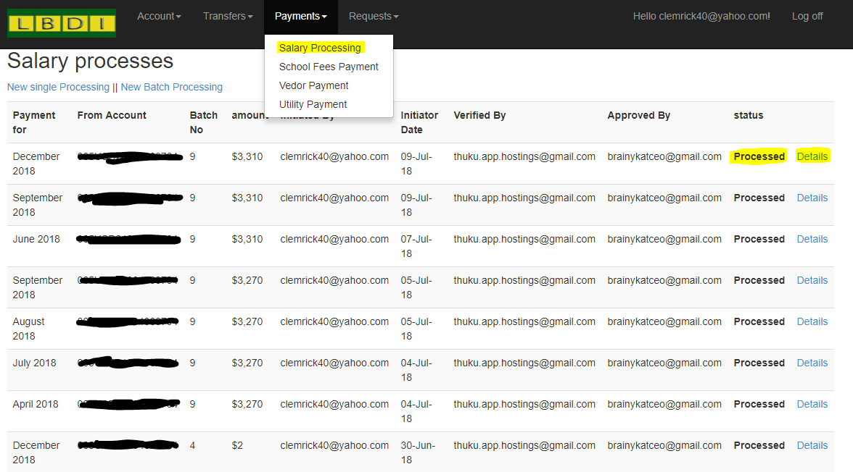

* On each you have a status column. This indicates the stage of the process
  + Initiated (Uploaded) by initiator
  + Verified by Verifier
  + Authorized by Authorizer
  + Processed
* You can click details link on each to view the records on each process and perform any action

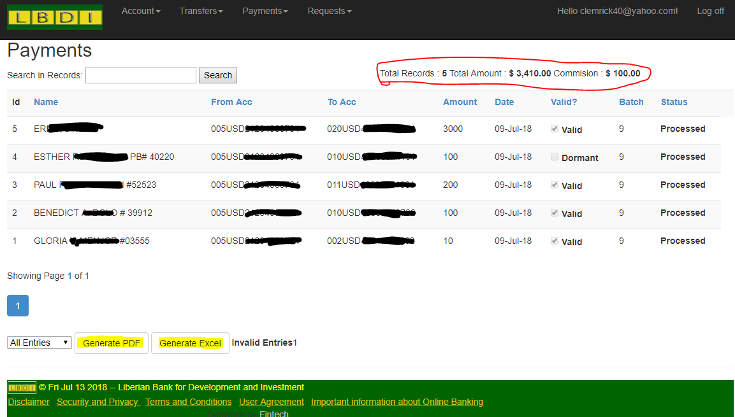

You can do a single salary processing entry or do the same in a batch.

Salary processing is procedural and divided into three stages

1. Initialization

The initiator does this. He/she uploads an excel document containing the batch details or just initialize a single salary payment.

* Single

Click on the “New single process link”

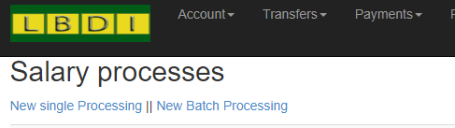

The below screen is displayed

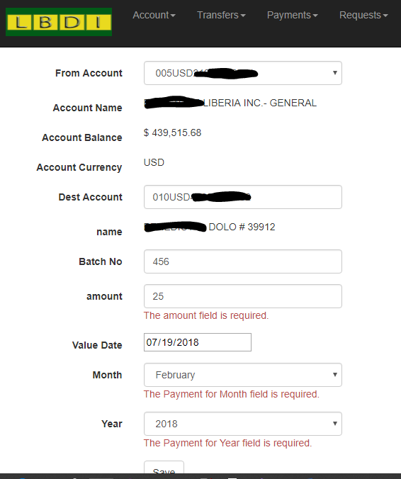

Fill in the details and click save.

* Batch Processing

Click on the “New Batch processing” link

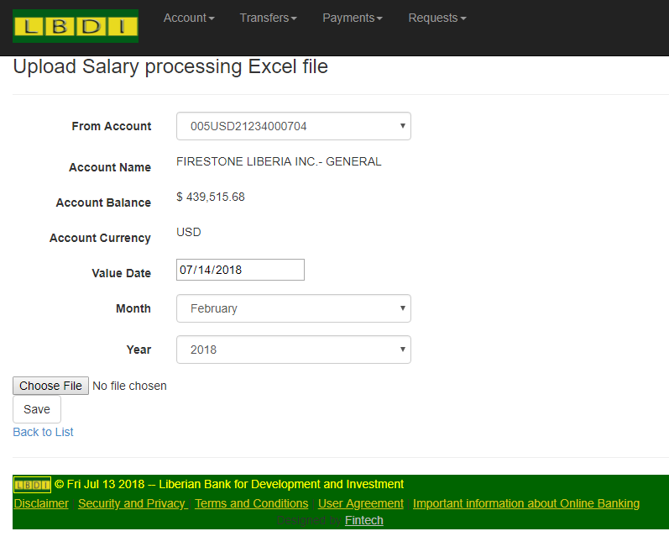

Choose the excel file to upload and click save

NB: The excel should be a document made from office 2013 and above of format (.xlsx).

The format should be as per the sample provided. i.e

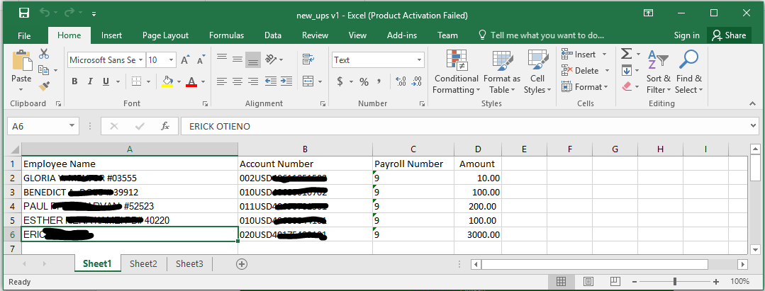

* + - Column 1 = Name
    - Column 2 = Account Number
    - Column 3 = (Your company payroll number)
    - Column 4 = Amount

The value date is the date the funds will be available to the employees account

After successful upload the system will open a details view of the document upload

All the records from excel file are show and a summation displayed

* Total Rows uploaded
* Total amount payable
* Total Commission payable
* Total Invalid entries if any

A record is invalid if any of below scenarios occur

* + - Employee account does not exist
    - Employee account is dormant
    - Employee account is of different currency with the debit account
    - Employee account is closed
    - Employee account is Debit only account.

This information is provide on column “Valid ?”

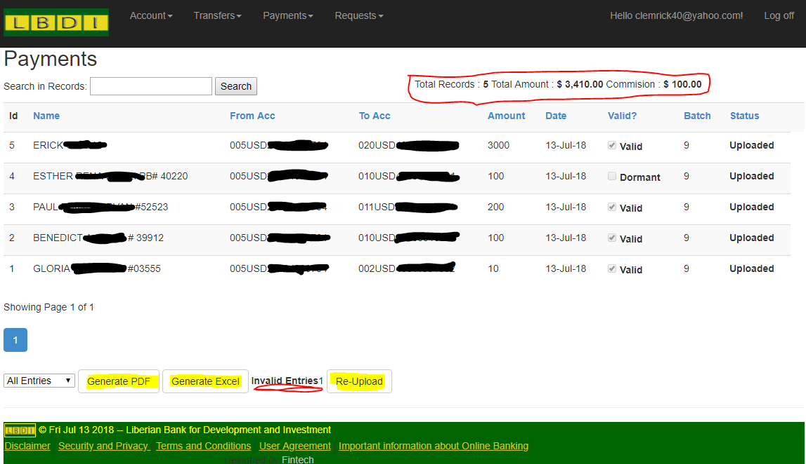

* The initiator can re-upload the excel if not satisfied with the results
* One can also generate upload reports of the same
* An email is sent to the Verifier and authorizer notifying them of the initialization so the can take the necessary actions.
* Leaving the upload as it is automatically qualifies it for the next step but only the valid entries are carried forward.

1. Verification

When the Verifier logs in the will see the salary process with status upload

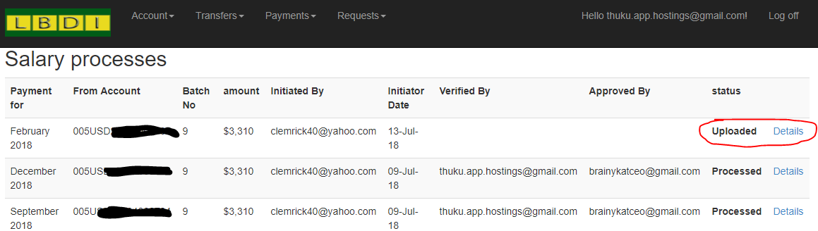

Click on details to view the records

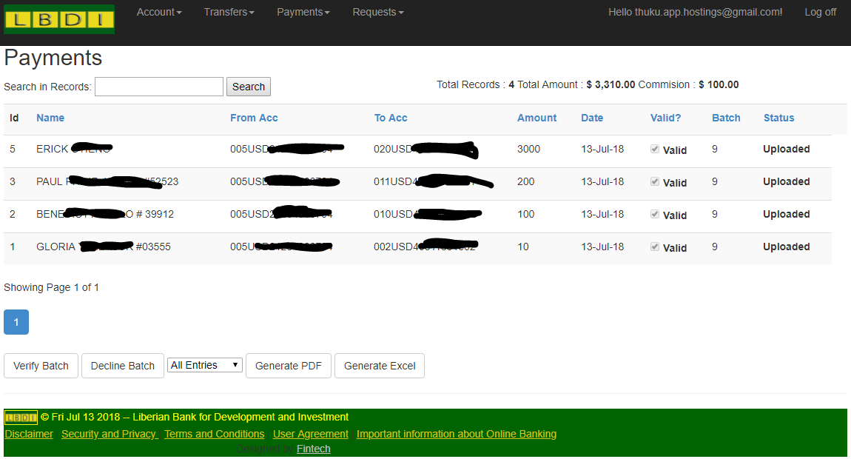

One can Verify or reject Batch

1. Authorization

When the Authorizer logs in they will see the below screen

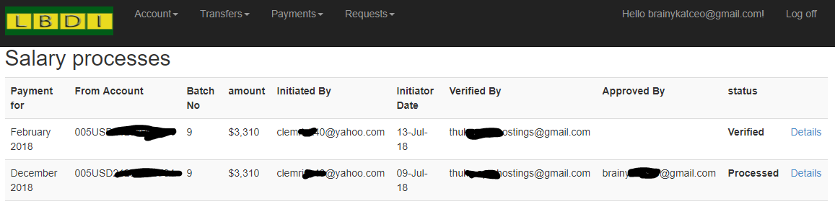

Click On details to see the batch records

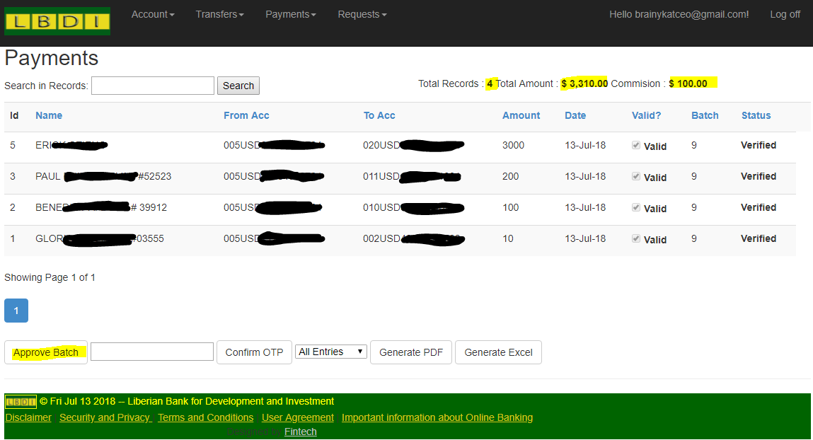

Click on Approve batch to authorize the batch.

You should Receive an SMS from LBDI with a One Time Pin (OTP)

Enter the OTP in the textbox and click “Confirm OTP”.

This completes the process but the funds are only availed to the employee after the value date.

## School fees payments

* Limited to single account holders only
* Payments menu school fees Payment.

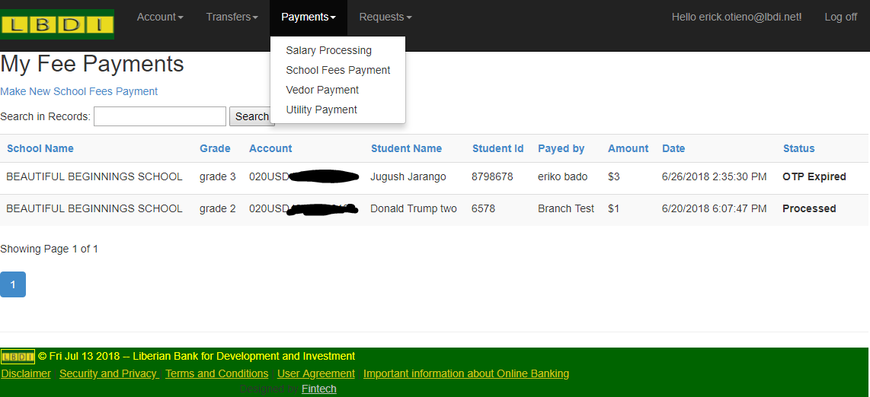

* A list of all previous payments if any is shown.
* To make new payment click link “Make New School fees payment

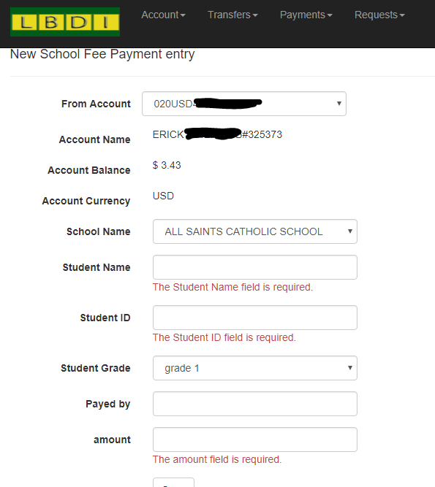

* Fill in the details and click save
* You will receive an OTP
* Confirm at and a PDF receipt will be auto generated.

## Vendor payments

Click on payment menu Vendor payment sub menu

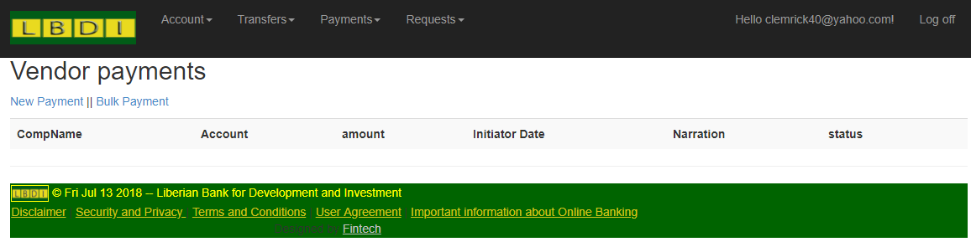

Follows the same procedure with salary Payment

## Utility payments

Click on payment menu Utility payment sub menu

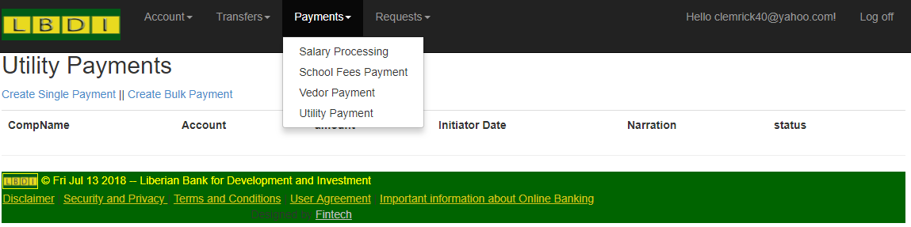

Follows the same procedure with salary Payment

# CHAPTER 5: REQUESTS

## Airtime Purchase

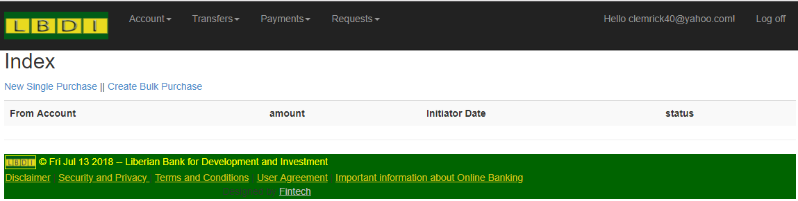

Single Airtime purchase – reserved for individual accounts

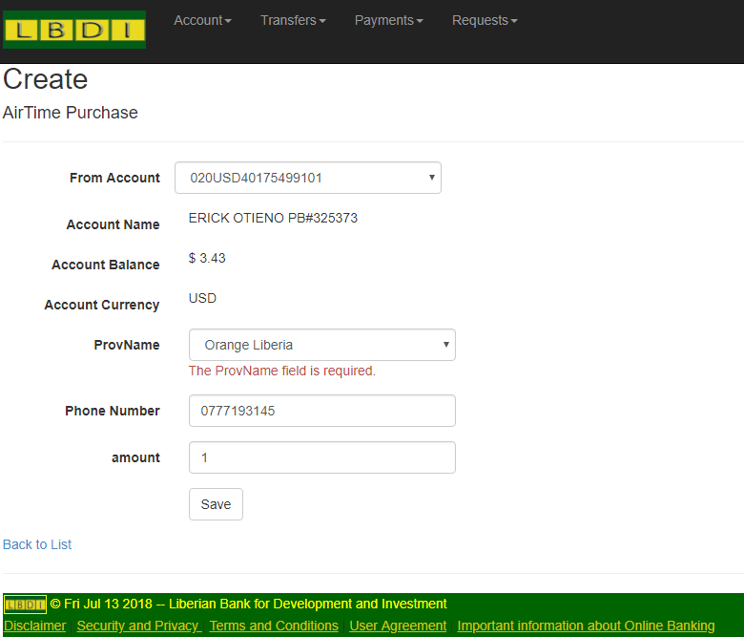

Bulk purchase – reserved for corporate accounts

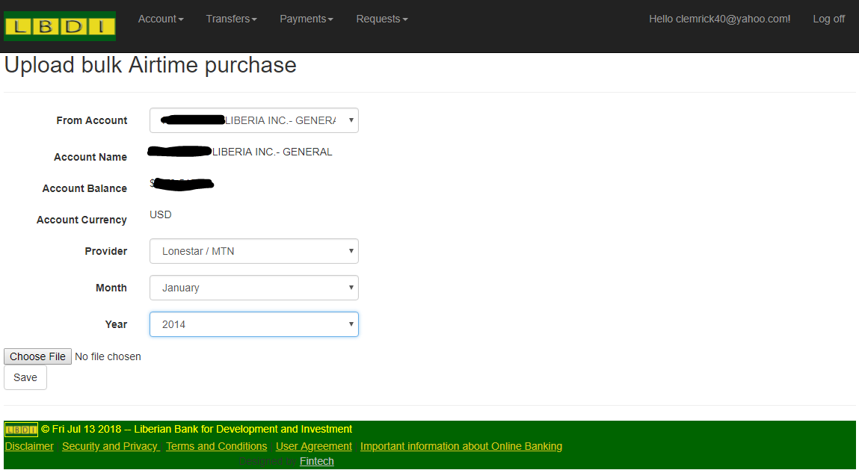

## Check book request

